Meta Title:
Authentic Ice Time Watch for sale-Limited Stock Available
Meta Description:
Are you looking for a new and Pre owned ice time watch for sale? Swiss Ice Co is your one-stop solution for buying real and authentic Ice time watches.
Watches Ice Time | https://swissiceco.com/collections/watches-ice-time | ice time watch  Pre owned ice time watch  ice time watch For sale  IceTime ROYAL Rose  IceTime watch for women  Men IceTime Watch
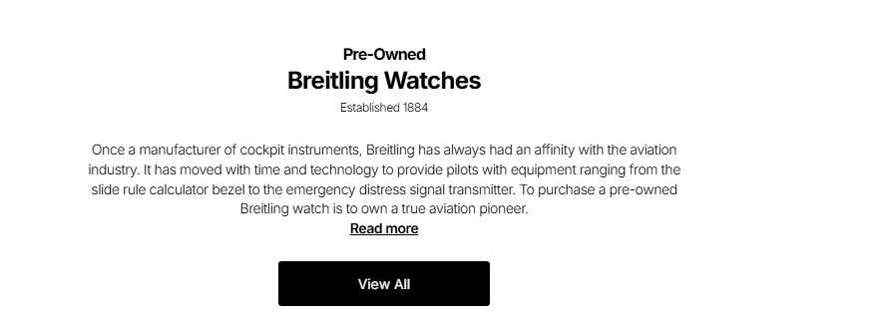
Ice Time Watch
At Swiss Ice Co, we understand and embrace the fact that luxury is a timeless experience. Our carefully selected stock of pre owned ice time watches represents the very best in traditional and modern watchmaking and offers unbeatable historical value for money. Every watch in our assortment has its history and creates a unique chance for those people who are interested in fine timepieces and would like to buy a true masterpiece at an affordable price.

Shop Now

Check Out Our Aesthetically Pleasing Ice Time Collection:
Every single time when you select an ice time watch for sale from the Swiss Ice Co company, you are not merely acquiring a piece of jewelry but a true timepiece with a history behind it. Each Ice Time watch in our collection has its own unique character and appeal that makes it so unique and special for the watch holder. Given below are some famous Ice Time models that are included in our collection:
- IceTime Maximus: The epitome of strength and of elegance ultimately. Perfect for people who expect others to notice them, this model represents the strength and great personality of the wearer.
- IceTime KING Yellow: A daring and sophisticated design where the yellow color used as a main component of watch design is more than different from the traditional perception of a watch.
- IceTime BLING: Most suitable for those people who like overdoses of chic. This model offers you just that ultimate glint and glitter on your wrist along with detailed workmanship complemented by dazzling shine.
- IceTime Royal Rose: Elegant and more subtle, this beautiful model serves up a rose-struck palette that carry unqiueness. Moreover, this model perfect for those individuals who like classic aesthetics with a modern twist.

Perfect Blend of Authenticity and Modernity:

Authenticity is one of the most important principles that form the basis of our company’s high reputation. Our watch experts understand very well the significance of authenticity because trust is a key factor in the fine art of the luxury timepiece industry. We aim at a higher level of authentication through multiple steps of examination when we buy any piece of Ice Time watch for women or men. Our skilled horological professionals analyze every wristwatch’s pedigree and study mechanism, movement, and paperwork to ensure each piece that we buy is authentic. In this regard, we assume full responsibility for the collection being fully transparent and guaranteeing only the highest quality and authenticity of each piece.

Why Are Pre-owned Watches Trending?
Aside from the technology and cost factors, there is something quite profound about owning a time-piece. Pre-own watches give us a link to the larger human experience, to an epoch of invention, of the master craftsmen who devoted their time to making them. In this sense, they are to remind us of the fact that ‘luxury’ does not mean expensive – it means more and better, it means the story behind the item, the work that has gone into its creation, and more importantly, the quality of the item to stand the test of time, not necessarily the trends of the moment.

Don’t Wait, Own Your Ice Time Watch Today!

When you select a watch from Swiss Ice Co, you are not just buying a watch. You are continuing the story, accepting history, and making a statement about your respect for true artistry. Every Men's IceTime Watch in our collection is the connection between the vintage and the modern, the personalized object of your perception of sophistication.

Our team is hereby poised to help you navigate through this remarkable process. Apart from the consultations, we also offer support and the assurance of ensuring that you get that timepiece that’ll be unique to your story. Whether this is your first time you buying Ice Time watch or you are an advanced collector, we warmly welcome you to our stores at San Francisco and Los Angeles to own your dream watch.

